Report
Of
Topic
E-Commerce Sales and Customer Analysis

Submitted
To
School of Computer Science and Engineering
IILM University, Greater Noida, U.P.

In partial fulfilment of the requirement of degree of
B.Tech CSE



By
Roll Number of Student:25SCS1003005137
Name of Student: DAKSH PATHAK
Batch:2CSE3

2026-27

CANDIDATE’S DECLARATION

I, Shivang Parashari do hereby declare that the internship report titled “E-Commerce Sales and Customer Analysis.” has been completed by me to fulfil the requirement for the award of the degree of Bachelor of Technology in CSE. All the references have been quoted and I have not taken as such any material from any other source. I affirm to you that this report is my own and has not been submitted to any other institute for any degree/diploma requirement and further I shall be solely responsible for any kind of copyright violation in this regard.

Signature
Student Name DAKSH PATHAK
Roll No.25SCS1003005137

ACKNOWLEDGEMENT

I am using this opportunity to express my gratitude to everyone who supported me throughout the Internship Program. I am thankful for their aspiring guidance, invaluably constructive criticism and friendly advice during this work. I am sincerely grateful to them for sharing their truthful and illuminating views on a number of issues related to this work.
I express my gratitude to my parents for their blessings.

Signature
Student Name DAKSH PATHAK
Roll No.._25SCS1003005137

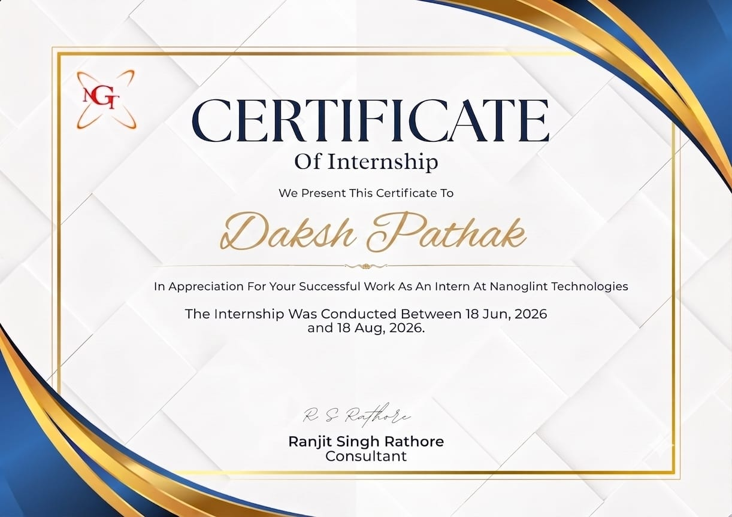

PROJECT DESCRIPTION
4.1 Introduction
As part of the internship at Nanoglint Technologies, the internship work focused on gaining practical exposure to software development concepts and applying technical knowledge to a real-world project environment. The project undertaken during the internship was based on the design and development of a web-based management system.
The project aimed to develop a simple, user-friendly and efficient web application capable of managing information digitally. It provided practical experience in understanding project requirements, designing the application interface, implementing functionality, handling data, testing the system and resolving errors.
The internship was conducted from 18 June 2026 to 18 August 2026, providing an opportunity to understand the complete development workflow and the importance of systematic software development.

4.2 Organization Profile
Nanoglint Technologies is a technology-oriented organization providing exposure to software and information technology-related activities. The organization focuses on practical implementation of technological concepts and provides an environment where interns can develop their technical and professional skills.
During the internship, the organization provided an opportunity to understand the software development process, including requirement analysis, application design, implementation, testing and documentation.
The internship helped in developing an understanding of how theoretical concepts learned in academics can be applied to practical projects.

4.3 Problem Statement
Managing information manually can be time-consuming and may result in errors, duplication of records and difficulty in retrieving required information. Traditional methods of maintaining records also make updating and organizing information difficult.
Therefore, there was a need for a simple web-based system that could organize information digitally and provide an easy interface for adding, viewing, updating and managing records.
The project was developed to address these issues by providing a centralized digital platform for efficient information management.

4.4 Project Objectives
The major objectives of the project were:
- To understand the complete software development life cycle.
- To design a simple and user-friendly web application.
- To provide an efficient method for managing digital records.
- To implement basic create, read, update and delete operations.
- To improve accuracy and reduce manual data-management efforts.
- To understand frontend and backend development concepts.
- To gain practical experience in database management.
- To perform testing and identify errors in the application.
- To improve problem-solving and debugging skills.
- To understand professional software-development practices.

4.5 Scope of the Project
The project provides a basic platform for managing information through a web-based interface. The scope of the project includes:
- User-friendly application interface.
- Digital storage and management of records.
- Adding new records.
- Viewing existing records.
- Updating information.
- Deleting unnecessary records.
- Searching and retrieving information.
- Basic input validation.
- Database connectivity.
- Testing and debugging of the application.
The system can further be extended by adding user authentication, role-based access, advanced search, reporting, cloud deployment and additional security features.

4.6 Technologies and Tools Used
The following technologies and tools were considered for developing the project:
Technology/Tool | Purpose
HTML | Structure of web pages
CSS | Designing and styling the interface
JavaScript | Adding interactive functionality
Python/Backend Technology | Implementing application logic
Database | Storing and managing records
VS Code | Writing and managing source code
Web Browser | Running and testing the application
Git/GitHub | Version control and code management
These technologies helped in understanding how different components of a web application work together.

4.7 System Architecture
The project follows a basic three-layer architecture consisting of the presentation layer, application layer and data layer.
1. Presentation Layer
This layer represents the user interface. HTML and CSS are used to create the structure and visual appearance of the application, while JavaScript provides interactive functionality.
2. Application Layer
The application layer processes user requests and contains the main business logic. It receives information from the user interface, performs the required operations and communicates with the database.
3. Data Layer
The data layer is responsible for storing and retrieving application data. It maintains records and allows the application to perform operations such as adding, viewing, updating and deleting information.
Basic architecture:
User → Web Interface → Application/Backend → Database
This architecture separates the different components of the application and makes the system easier to maintain and develop.

4.8 Methodology
The project was developed using a systematic approach. The major stages followed during the development process were:
Requirement Analysis
The requirements of the system were identified and the major features needed in the application were determined.
System Design
The structure of the application, user interface and database requirements were planned before implementation.
Development
The frontend and backend components were developed using appropriate technologies. The required functionality was implemented step by step.
Database Implementation
A database structure was designed to store and manage the required records efficiently.
Testing
Different features of the application were tested to identify functional errors, input-related problems and unexpected behaviour.
Debugging
Errors identified during testing were analysed and corrected to improve the reliability of the application.
Documentation
The development process, technologies used and project outcomes were documented as part of the internship report.

4.9 Expected Outcomes
The project was expected to provide the following outcomes:
- A functional web-based information management system.
- Improved understanding of web application development.
- Better understanding of frontend and backend technologies.
- Practical knowledge of database operations.
- Improved debugging and problem-solving skills.
- Reduction in manual record-management efforts.
- Better organization and retrieval of information.
- Practical understanding of software development methodologies.
- Experience working on a project in a professional environment.
The internship also helped bridge the gap between theoretical academic knowledge and practical industry-oriented implementation.

4.10 Certificates of Completion and Other Communication Proof
A copy of the Internship Completion Certificate issued by Nanoglint Technologies is attached with the report as proof of successful completion of the internship.
According to the certificate, Parth Kumar successfully completed the internship at Nanoglint Technologies from 18 June 2026 to 18 August 2026. The certificate was issued in appreciation of the successful work performed during the internship.
Any relevant communication emails, internship-related instructions, project discussions or other supporting documents may also be attached in this section as required by the institute.
BIBLIOGRAPHY / REFERENCES
- Mozilla Developer Network (MDN), “HTML: HyperText Markup Language”, MDN Web Docs.
- Mozilla Developer Network (MDN), “CSS: Cascading Style Sheets”, MDN Web Docs.
- Mozilla Developer Network (MDN), “JavaScript Guide”, MDN Web Docs.
- Python Software Foundation, “Python Documentation”, Python Official Documentation.
- W3Schools, “HTML, CSS, JavaScript and Python Tutorials”, W3Schools.
- GeeksforGeeks, “Web Development and Programming Tutorials”, GeeksforGeeks.
- GitHub Documentation, “GitHub Documentation and Version Control”, GitHub.
- Visual Studio Code Documentation, “Visual Studio Code Documentation”, Microsoft.
- Elmasri, R. and Navathe, S. B., Fundamentals of Database Systems, Pearson Education.
- Pressman, R. S., Software Engineering: A Practitioner’s Approach, McGraw-Hill Education.
Web References
- MDN Web Docs – HTML, CSS and JavaScript
- Python Official Documentation
- W3Schools – Web Development Tutorials
- GeeksforGeeks – Programming and Computer Science Resources
- GitHub Documentation
- Visual Studio Code Documentation

